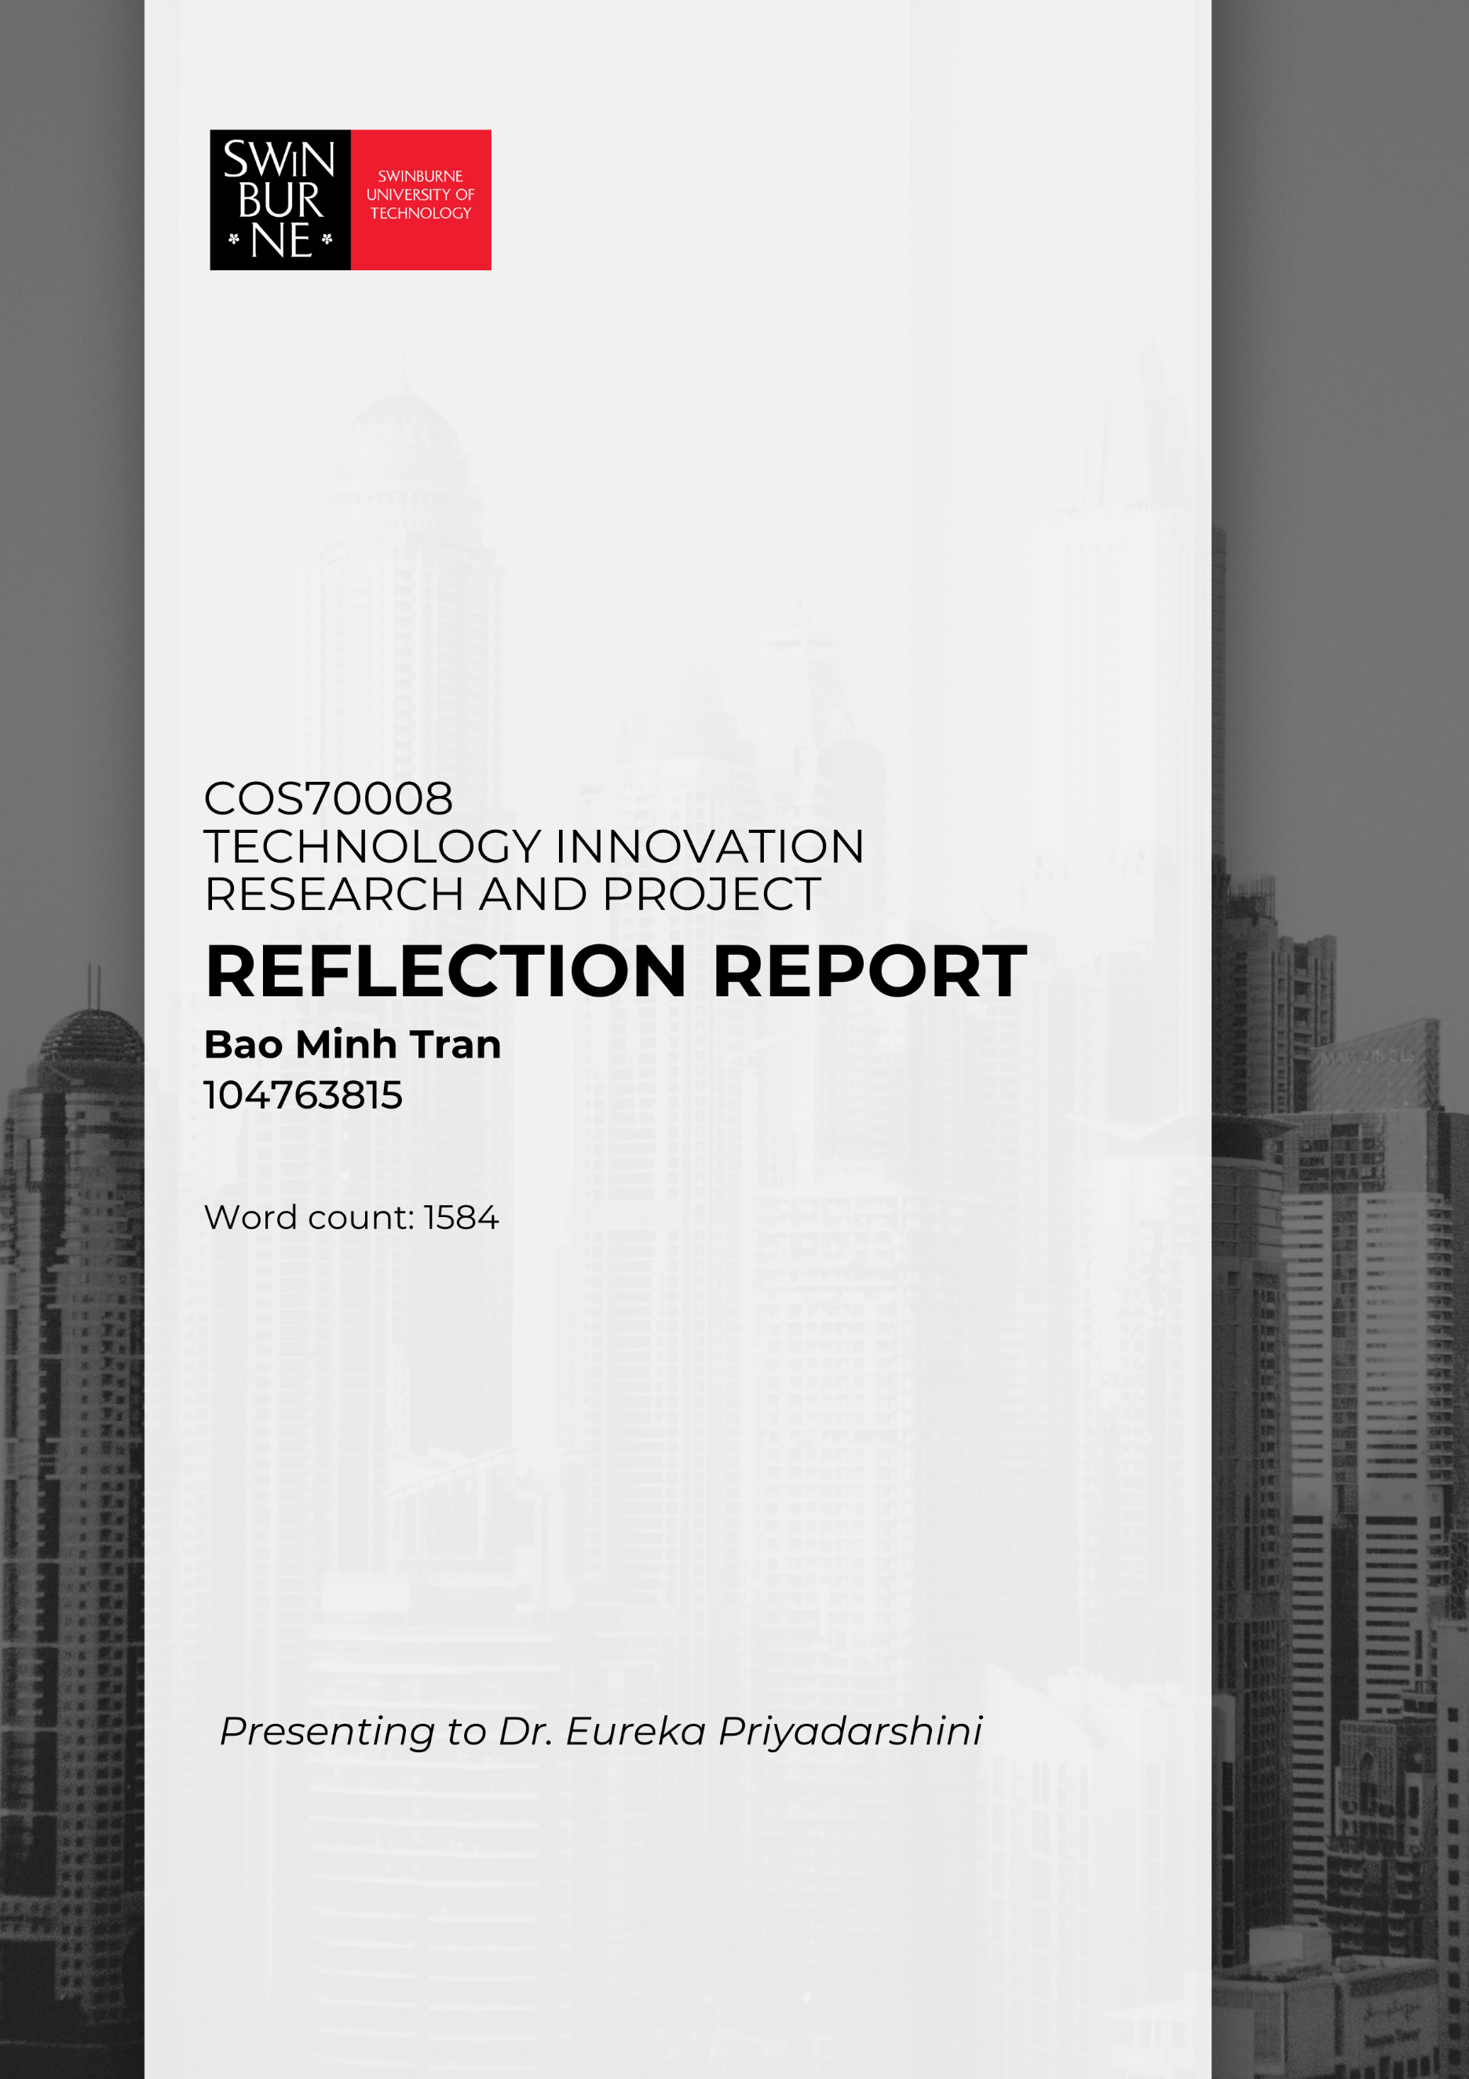

**Table of Contents**

1. Group Work Reflection 3

1.1 Group Strategies That Worked 3

1.2 Group Strategies That Didn't Work 3

1.3 Improvements for Next Time 4

1.4 Outstanding Team Actions 4

2. Individual Work Reflection 6

2.1 Project Tasks Across All Phases 6

2.2 Contributions to Group 8

2.3 Conclusion and Recommendation 9

3. References 10

4. Appendix: 10

**Table of Figures**

Figure 1: Trello tasks divided for each team member. 3

Figure 3: GAT Model Architecture – Input features processed by multiple attention heads, producing node and edge predictions. 6

Figure 4: System/Data Flow – Clearer layout, color coding, and labeled arrows for data and user input 7

Figure 5: Conceptual Network Graph – All relationships are clearly labeled, and a legend is included 8

## 1. Group Work Reflection

### 1.1 Group Strategies That Worked

Our team employed a mix of communication and project management tools to collaborate effectively. We primarily used WhatsApp for daily updates and quick coordination (Appendix 1). Trello served as our task management platform, where we divided responsibilities and visually tracked progress. For version control and code integration, we relied on GitHub, which streamlined collaboration. Meetings were conducted on Microsoft Teams (Appendix 2), allowing us to make group decisions and clarify misunderstandings efficiently.

Task allocation was based on team members' strengths. Following our Week 6 meeting, I, along with Sakshyam, volunteered to lead the development of the Graph Attention Network (GAT) algorithms. Maleesha and Dona focused on generating a synthetic dataset, while other team members supported research and selected the technologies for our application.

Throughout the first seven weeks, our team maintained steady progress. Regular slide preparation and synced GitHub updates ensured alignment. Trello helped us monitor dependencies, deadlines, and deliverables.

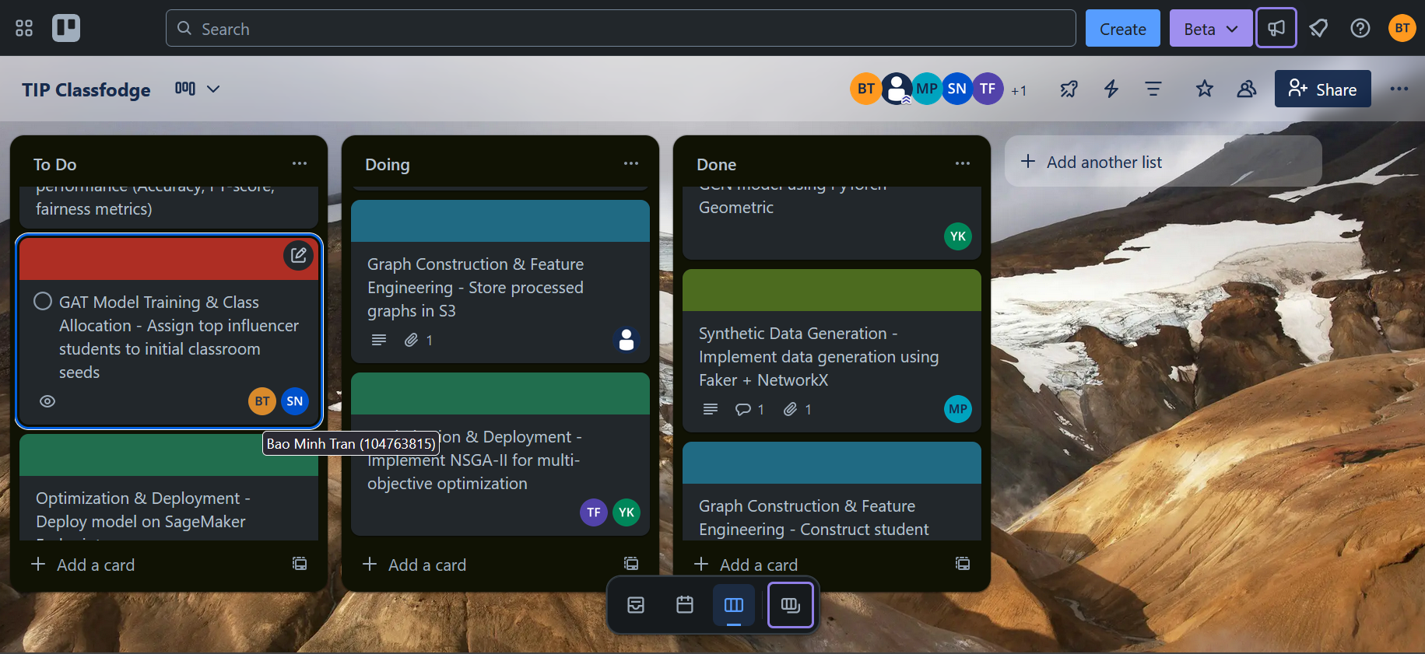

Figure 1:Trello tasks divided for each team member.

### 1.2 Group Strategies That Didn't Work

Despite our efforts, several issues hindered progress. In Week 2, I proactively began development after learning from the lecturer that delays were common. I encouraged early task division, but my advice was initially dismissed in favor of focusing on individual reports. As a result, progress was delayed until Week 9.

I had built a real-time working version with an integrated frontend, backend, and GAT model. However, two members insisted on switching to a simpler synthetic dataset. Although I adjusted my implementation to accommodate this, my updates, uploaded to GitHub, were not used (Appendix 3). During our client presentation, the synthetic-based app had only one bar graph, with no implemented model or visualizations. Feedback from the client emphasized the need for substantial improvement, which validated my earlier suggestions.

Unfortunately, the lack of communication and timely integration led to missed opportunities. I later demonstrated the full version, including visualizations and model performance, which helped us regain some ground.

### 1.3 Improvements for Next Time

Going forward, I plan to enhance my communication and influence within group settings. Although I contributed heavily in terms of design, coding, and model development, I struggled to gain buy-in from the team. I intend to improve my assertiveness and presentation skills by studying communication strategies and practicing confidence-building techniques.

While I successfully managed my tasks, I recognized the importance of team alignment. Documenting contributions more visibly on Trello or GitHub and confirming mutual task commitments earlier would help avoid miscommunication (Appendix 8).

To manage conflict better, I focused on being adaptable and receptive to peer input (Appendix 10). However, I learned that addressing disagreements early, constructively, can yield better outcomes than staying silent.

### 1.4 Outstanding Team Actions

#### Team Organization

In Week 3, Deelaka, Maleesha, and Dona established the organisational framework. Deelaka created and managed the Trello board, assigning tasks with weekly deadlines. Maleesha and Dona classified tasks into "Data Processing," "Model Development," and "Visualization," and together they implemented a GitHub issue template to log and prioritize feature requests. From Weeks 4–10, all six members rotated bi-weekly status-report emails, detailing completed tasks, challenges, and upcoming objectives (Appendix 11), thereby preserving momentum and accountability.

#### Meetings

In Week 6, Sakshyam, Bao Minh, and the team met via Microsoft Teams to finalise the tech stack (Appendix 4). I demonstrated my Next.js/TypeScript/Tailwind prototype—covering JSON endpoints, React graph components, and Chart.js integration—using a realistic dataset (Appendix 7). Maleesha and Dona then requested a synthetic dataset; I adapted my pipeline accordingly in Weeks 6–7 (Appendix 9). That session cemented our dual-head GAT approach and guided subsequent development.

#### Delivery of Project Design Ideas

In Week 7, I led and presented the project design before our class tutorial. I outlined:

* System architecture (GAT → Flask → Next.js/React)
* Pseudocode for node/edge generation
* UI mockups (hover interactions, chart behaviors)

(Appendix 12)

Following my demonstration, Sakshyam, Maleesha, Sam, and Dona integrated and extended these concepts. Maleesha's synthetic-data analysis (e.g., stochastic block modeling vs. k-nearest neighbors) and my explanation of attention-weight visualization informed the Week 8 prototype.

#### Delivery of Innovation Concept

In Week 9, the team produced the "Innovation Concept" document. Deelaka, Maleesha, Sakshyam, Dona, and Yasasi covered design concepts, methodology, and constraints, each outlining five design ideas and specifications. I authored the Evaluation/Justification, citing GAT literature and visualization best practices. Although the content met the requirements, it was of average depth and submitted late, incurring a 2.5-point penalty.

#### Research Support

Dona conducted a literature review on GAT, stochastic block modeling, and community detection, guiding network design and hyperparameter selection. Maleesha researched visualization best practices (PyVis, Chart.js, color schemes) and prototyped chart layouts in Figma. Their combined efforts ensured academic rigor and user-experience alignment.

#### Delivery of Final Presentation

In Week 11, I structured the slide deck into six sections: (1) Problem Statement, (2) ClassForge – Our AI-Powered Solution, (3) Data Pipeline, (4) Visualization Methods, (5) Live Demo, and (6) Limitations & Future Work (Appendix 15). Appendix 16 assigned roles and each member executed their part effectively:

* Sakshyam: Problem Statement
* Yasasi: AI-Powered Solution (GAT, SBM, PuLP)
* Maleesha & Deelaka: Visualization Methods & Live Demo (PyVis, Chart.js)
* Bao Minh: Limitations & Future Work (synthetic-data constraints, next steps) (Appendix 13)

All presenters delivered their sections professionally, and the live Flask to PyVis/Chart.js demonstration ran smoothly, reflecting strong collaboration and adherence to rubric criteria.

## 2. Individual Work Reflection

### 2.1 Project Tasks Across All Phases

#### Phase 1 (Week 1–4): Initial Research and Ideation

I began by researching graph-based allocation methods and sketching system architecture (Appendix 12). Drawing on my proficiency with Next.js, TypeScript, and Tailwind, I set up a front-end prototype: a page that could fetch JSON data from a Flask endpoint (to be built later) and render a basic network visualization placeholder. Simultaneously, I designed a PostgreSQL schema and wrote Python scripts to ingest a real student dataset, normalizing features, and constructing a graph structure for a Graph Attention Network (GAT). By the end of Week 4, I had a working Next.js frontend scaffold and a Python-based GAT training pipeline.

GAT Model Architecture

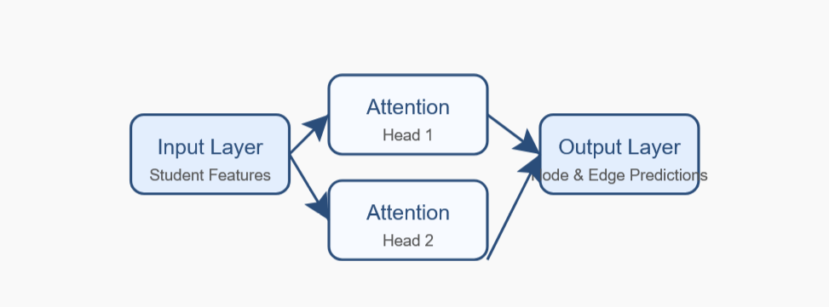

Figure 3: GAT Model Architecture – Input features processed by multiple attention heads, producing node and edge predictions.

As illustrated in Figure 1, the GAT model architecture processes student features through multiple attention heads, enabling the model to learn both node and edge predictions effectively.

#### Phase 2 (Week 5–7): Prototyping, Design Creation

During this phase, I fully implemented the dual-head GAT model in PyTorch Geometric. I wrote Python functions to build the student graph—using peer-similarity edges and synthetic conflict/friendship edges—and to train the GAT for both exam score prediction and edge-type classification. On the frontend side, I continued developing my Next.js + Tailwind interface: fetching node and edge data from a Flask route (/api/run-gat) and rendering it with a placeholder React graph library (to demonstrate live data flow). I also built React components that would later be replaced with D3 or PyVis, such as <NodeTooltip> and <ChartContainer>. Meanwhile, I used the synthetic dataset generated by our group.

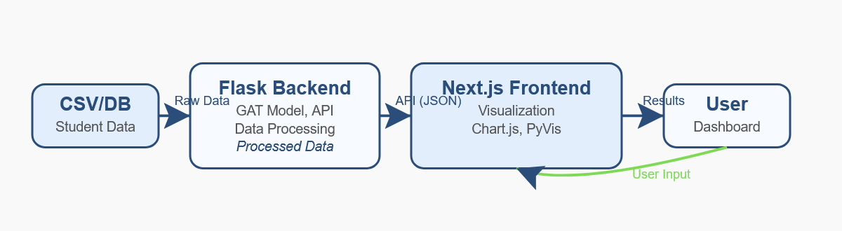

Figure 4: System/Data Flow – Clearer layout, color coding, and labeled arrows for data and user input

#### Phase 3 (Week 8–10): Implementation, Testing

I completed my original Next.js/TypeScript/Tailwind application by integrating a React-D3 graph visualization (showing nodes colored by predicted class and edges colored by relationship type) and embedding Chart.js bar charts for class-size distribution (Appendix 17). I also perfected the Flask backend: a /run-gat endpoint that returned embeddings, attention weights, and edge predictions in JSON. I wrote unit tests to verify that the GAT output matched expected dimensions and that the Next.js frontend correctly displayed dummy data from Flask. Throughout testing, I measured model accuracy, optimized hyperparameters (learning rate, number of attention heads), and iterated on my React components to ensure the interactive graph and charts performed smoothly. I documented everything in a README with setup steps—covering Docker, environment variables, Neo4j credentials, and Next.js build commands.

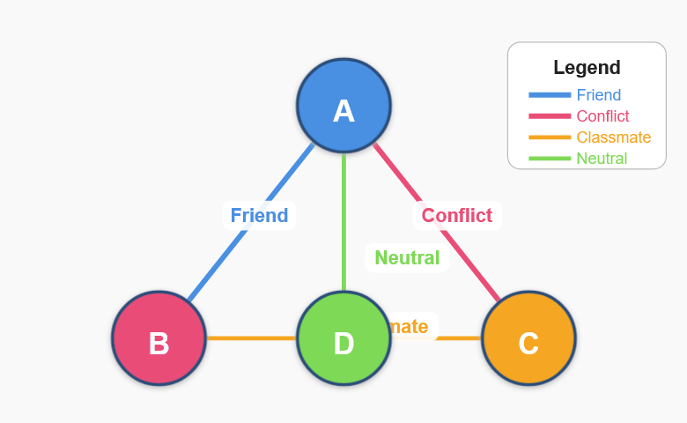

Figure 5: Conceptual Network Graph – All relationships are clearly labeled, and a legend is included

#### Phase 4 (Week 11): Final Presentation and Documentation

In the final week, the team presented their Flask-based application—using Flask, Jinja2, PyVis, and Chart.js, explicitly modeled on the methods and visual features I had developed with my Next.js/TypeScript/Tailwind prototype. I collaborated to ensure they adapted my JSON-export endpoints, modular GAT functions, and data-formatting logic correctly. I reviewed their Flask code to confirm node/edge/attention-weight structures matched my design. They then used PyVis (nodes colored by class, edges by relationship type) and Chart.js (interactive allocation charts). During rehearsals, I guided the live-demo setup (hover interactions and drill-down charts). On presentation day, their Flask/Jinja2 application ran seamlessly, satisfying all requirements.

### 2.2 Contributions to Group

Throughout the project, I contributed to both the technical and collaborative aspects of our group work. I led the development of the GAT model and the frontend prototype, ensuring our solution was robust and user-friendly. I regularly shared progress updates, provided technical support to team members, and helped integrate their work into the main codebase. My efforts in documentation, code reviews, and live demonstrations helped maintain project momentum and foster a collaborative environment. I also adapted my work to accommodate team feedback and changing requirements, demonstrating flexibility and commitment to group success.

### 2.3 Conclusion and Recommendation

In summary, my involvement in the project enabled me to deepen my technical skills in full-stack development, collaborative problem-solving, and agile teamwork. By contributing to both the backend GAT model and the frontend visualization, I ensured our solution was robust, user-friendly, and aligned with the client's needs. The experience also enhanced my ability to communicate complex ideas and adapt to evolving project requirements.

For future projects, I recommend dedicating more time to early-stage design discussions and cross-team code reviews. This would help surface integration issues sooner and foster a stronger shared understanding of the system architecture. Additionally, I would seek more frequent feedback from end-users to ensure our solutions remain closely aligned to their expectations.

## 3. References

* Velickovic, P., Cucurull, G., Casanova, A., Romero, A., Lio, P., & Bengio, Y. (2018). Graph Attention Networks. *arXiv preprint arXiv:1710.10903*.
* PyTorch Geometric Documentation. https://pytorch-geometric.readthedocs.io/
* Chart.js Documentation. https://www.chartjs.org/docs/latest/
* Neo4j Documentation. https://neo4j.com/docs/

## 4. Appendix:

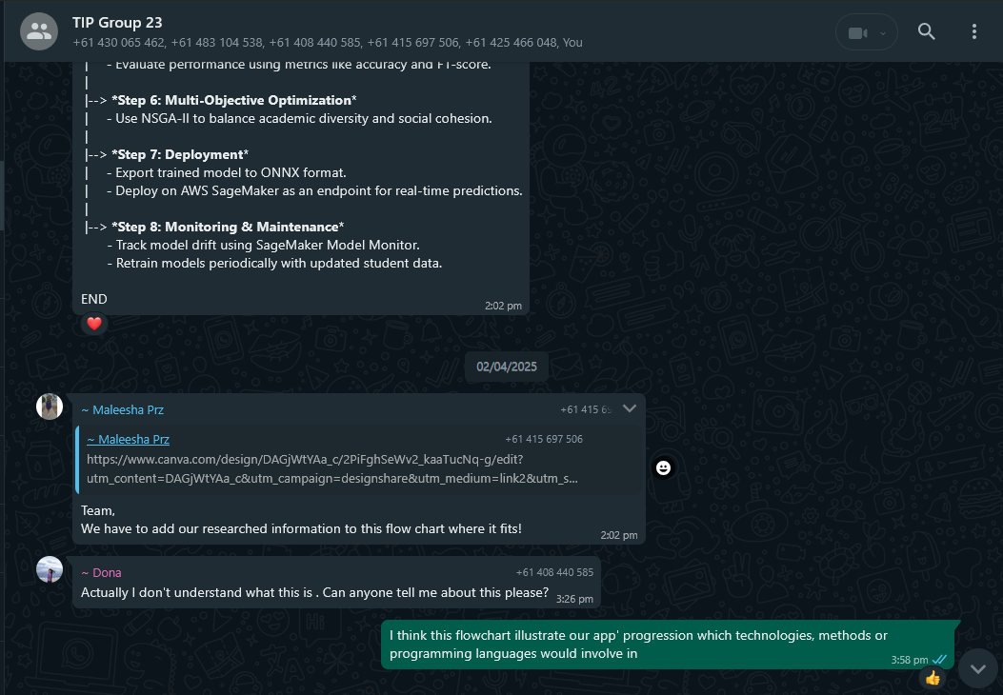

Appendix 1: Supporting a team member for clarification.

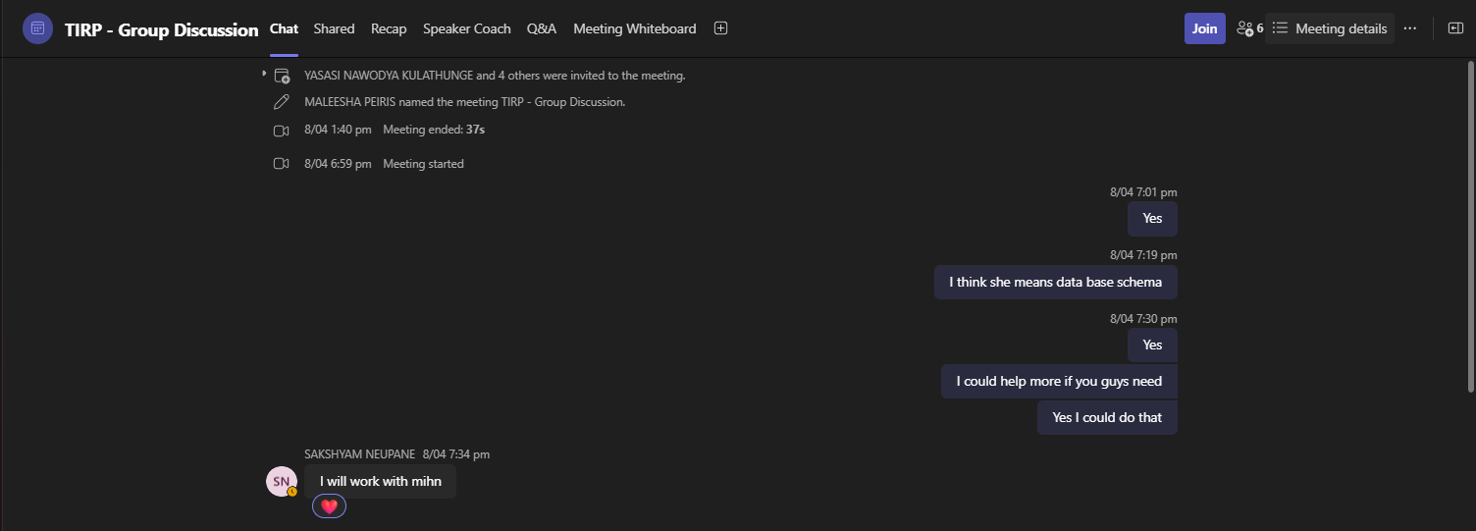

Appendix 2: Team communication through Microsoft Teams.

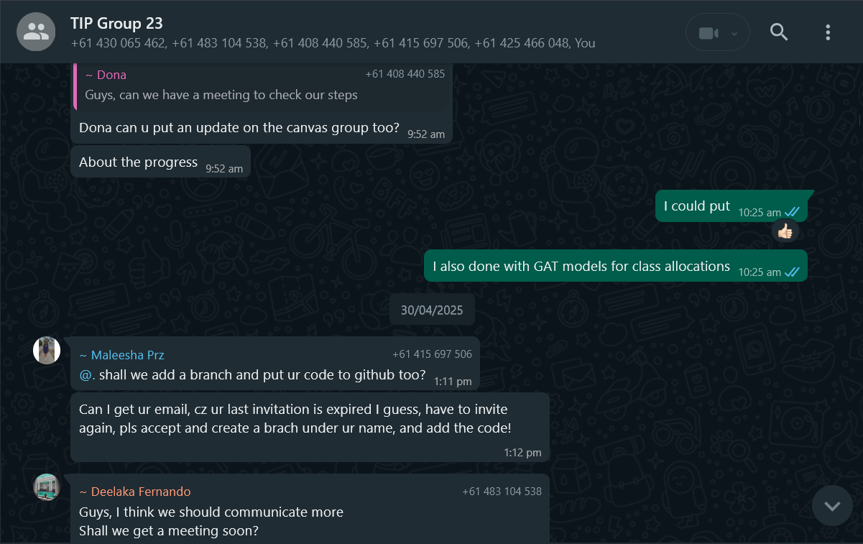

Appendix 3: The update about GAT model completion.

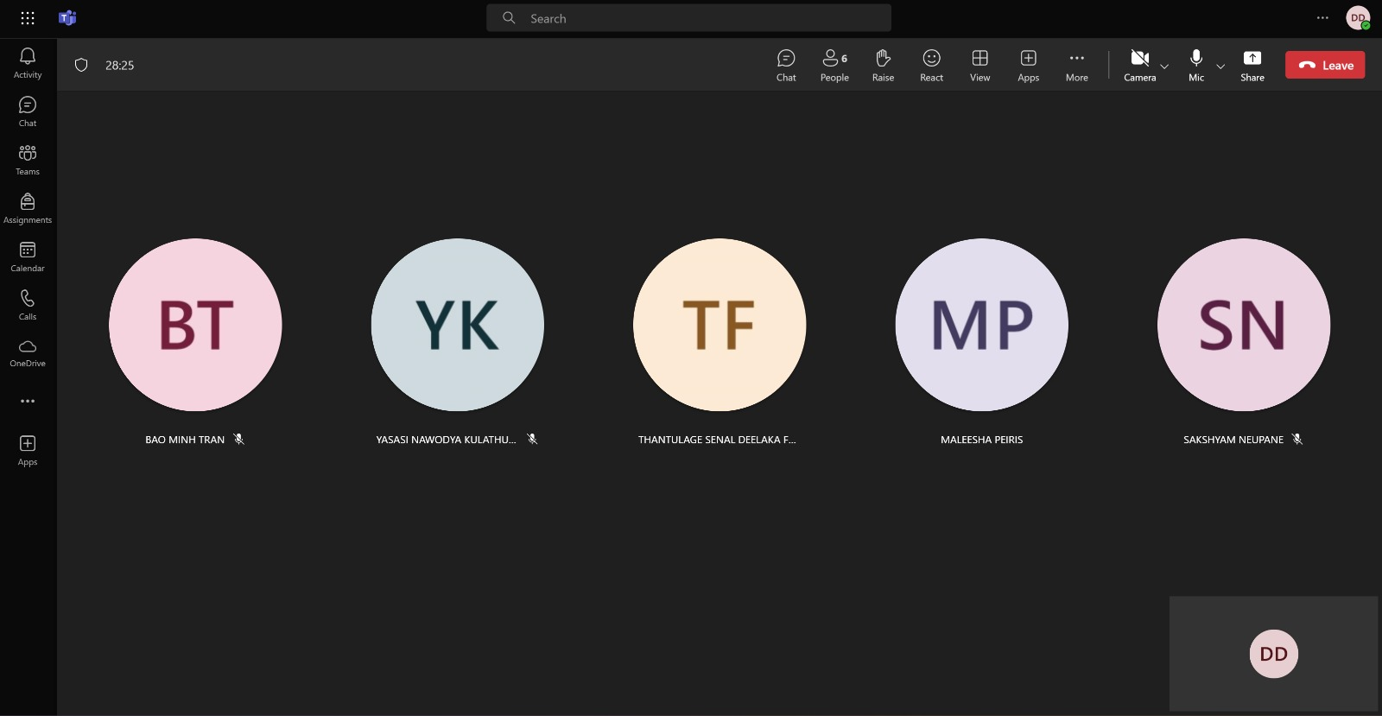

Appendix 4: Meeting in Microsoft Teams to discuss the team's progress.

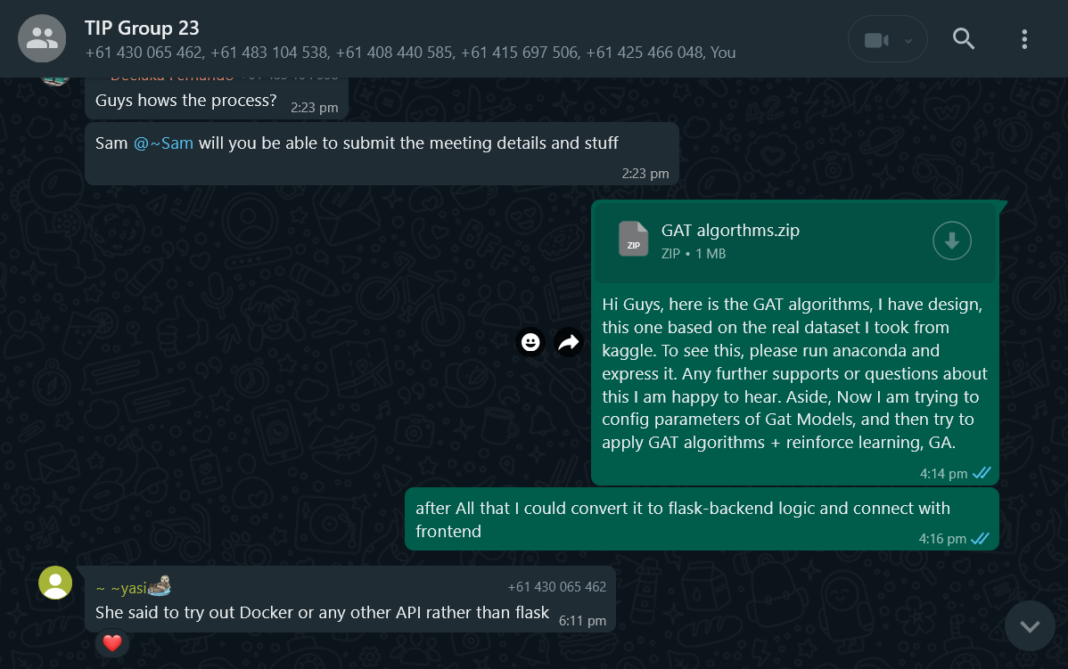

Appendix 5: Contributions to the GAT Algorithms development, using real-time dataset from Kaggle.

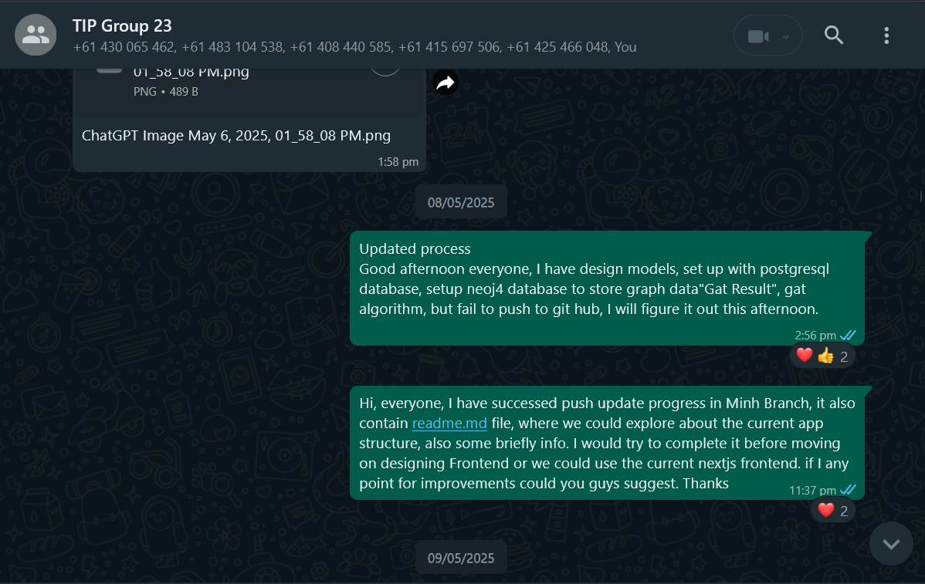

Appendix 6: Updating about progress of the web application development.

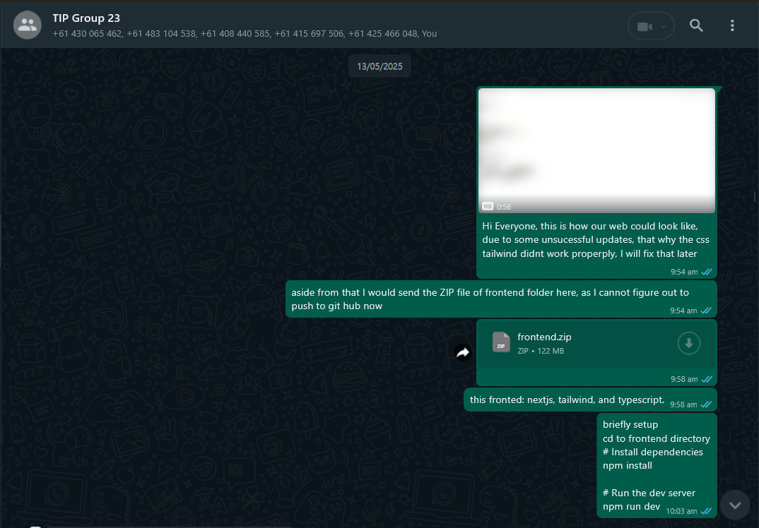

Appendix 7: Codes of Frontend using next.js, tailwind, and TypeScript.

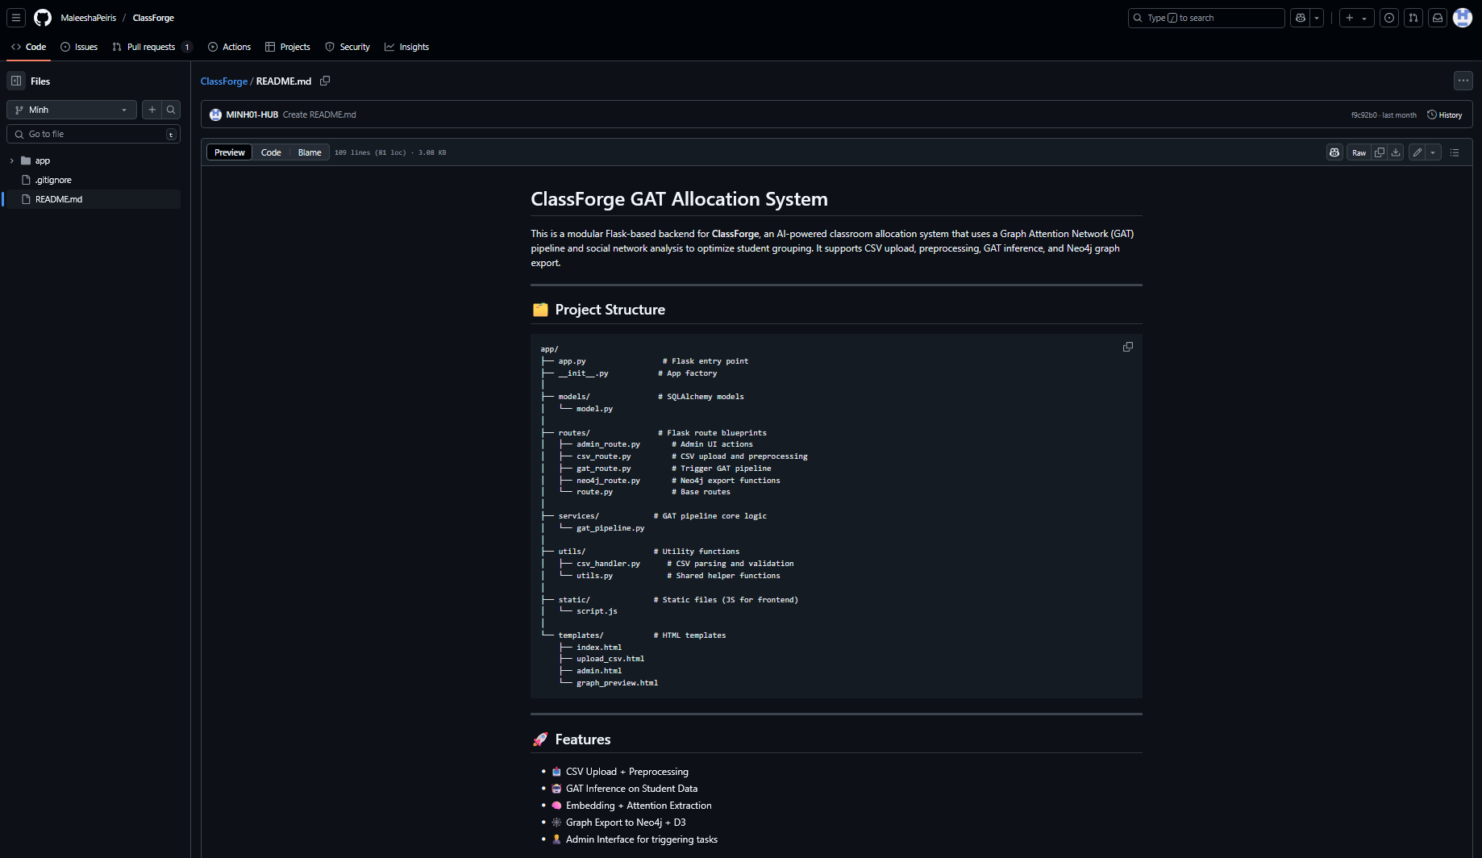

Appendix 8: Readme.md file on Github of the Minh Branch, showing structures of files in the applications.

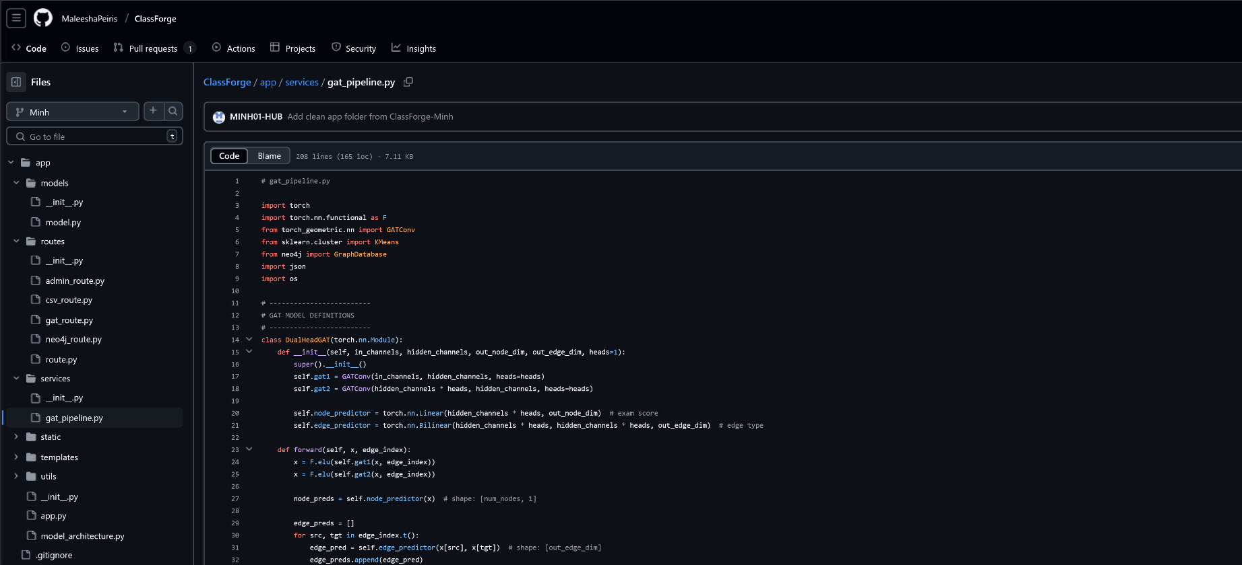

Appendix 9: Files of the Classforge application, using the synthetic dataset of Minh branch on git hub.

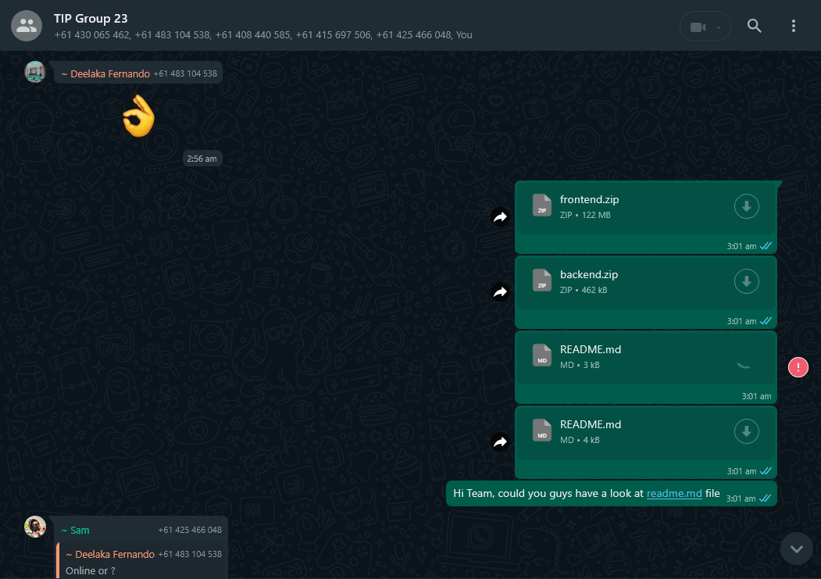

Appendix 10: The heavy frontend and backend directory were uploaded on Whatsapp unsuccessfully.

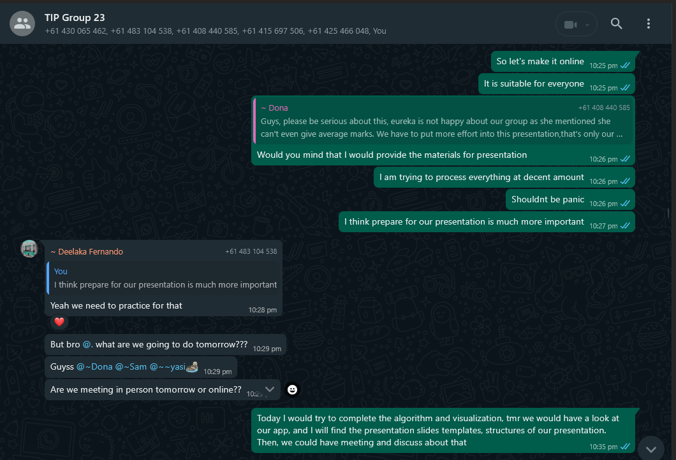

Appendix 11: Encourage team members to follow the application plan.

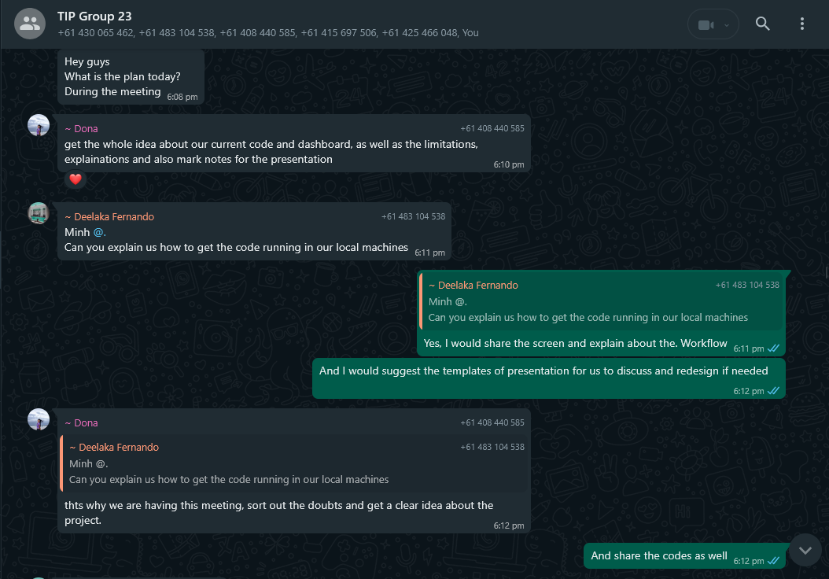

Appendix 12: Explaining about the workflow of application, and GAT Algorithm.

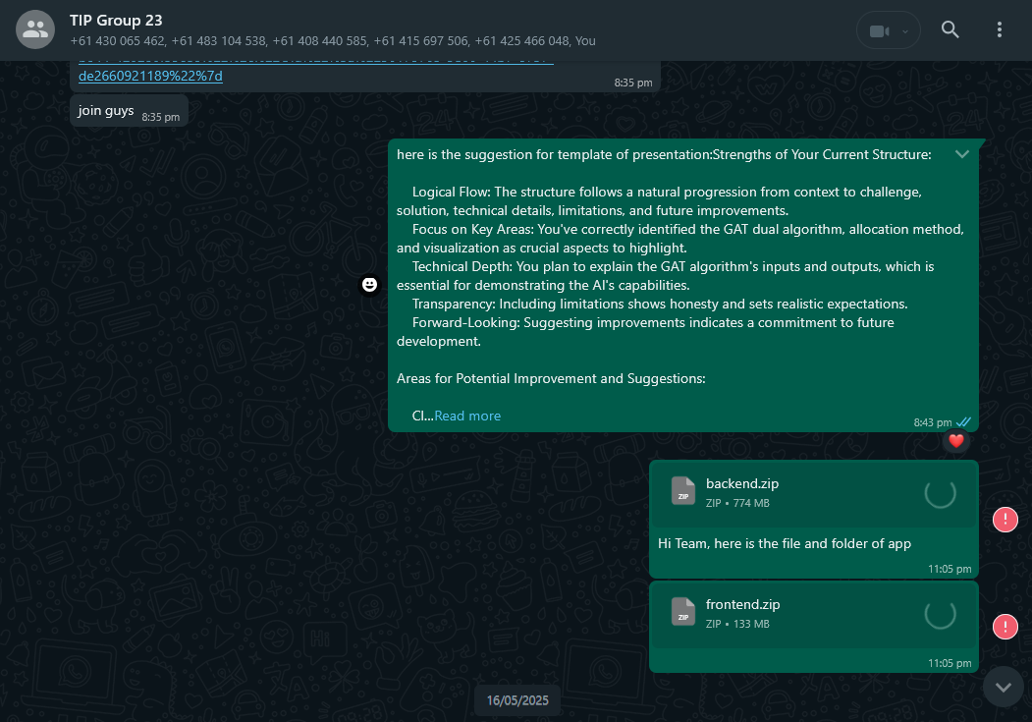

Appendix 13: Suggestions for the backbone of Final Presentation.

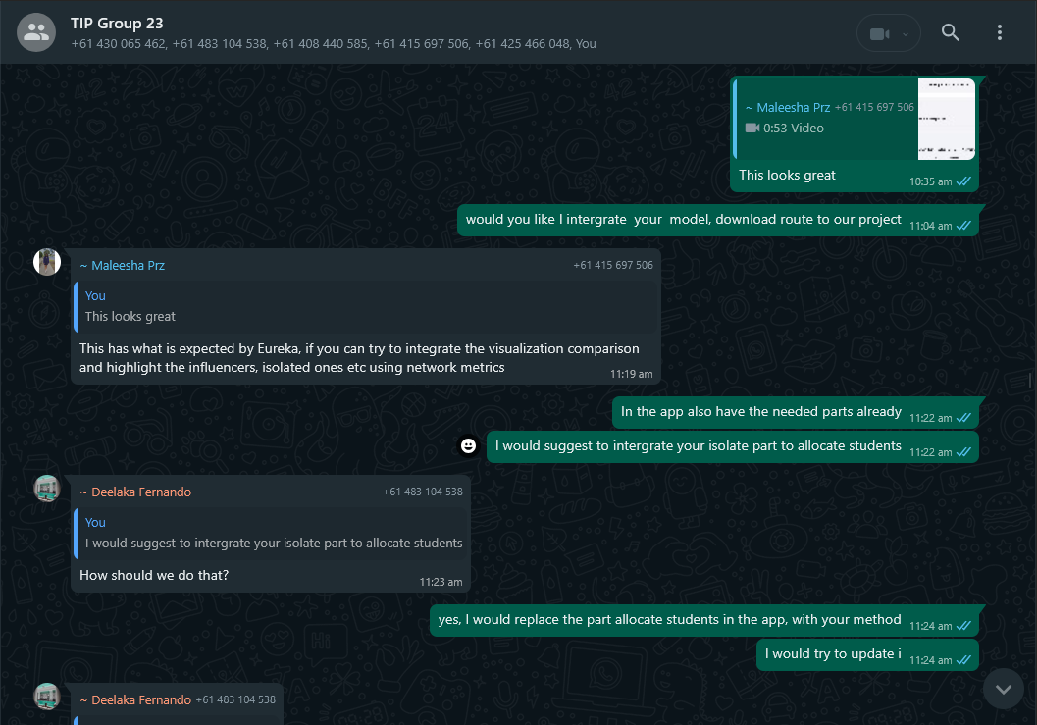

Appendix 14: Integration of allocation method to the final one.

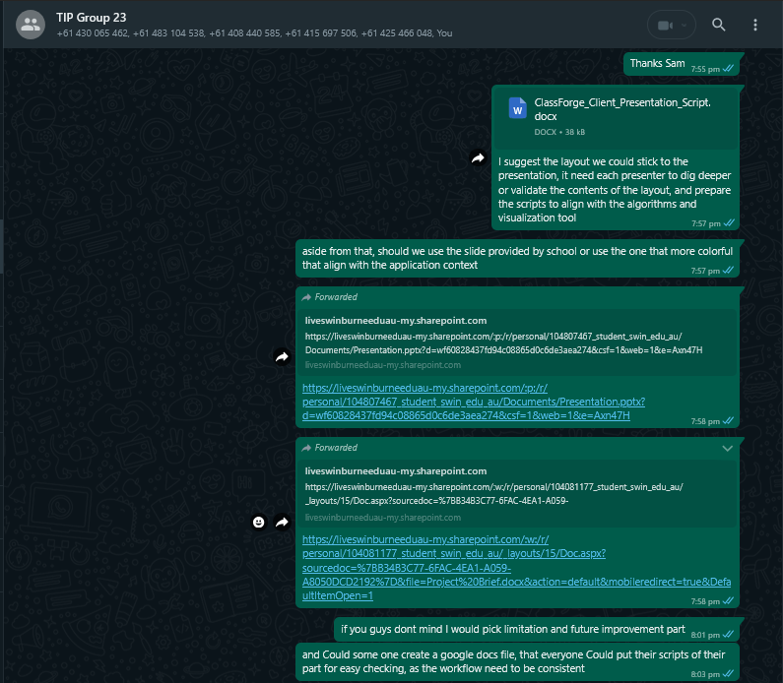

Appendix 15: Designing the structure of the final presentation.

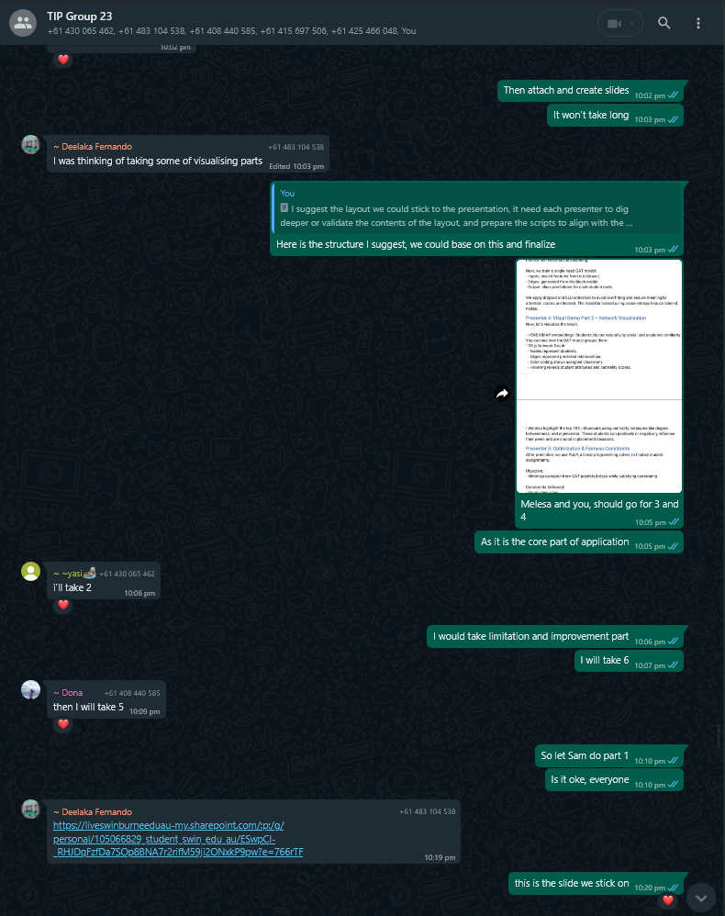

Appendix 16: Distribution of presentation.

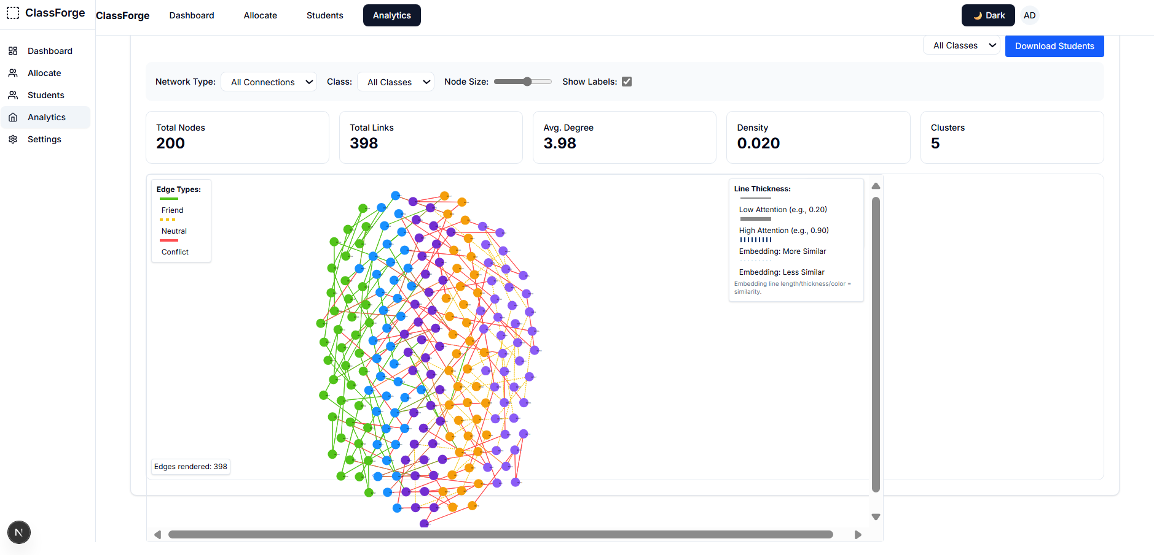

Appendix 17: My Blueprint application for the team to refer.